**“The SHERP - Interview app”**

The SHERP app helps interviewers conduct interviews and then save the interview data in the device for a later upload to the server.

The UI of the SHERP app has been built keeping Digiflip pro tablet in mind. However, it would run smoothly on other tablets too. But devices with screen sizes <> 7 will have UI display issues. However, this will be taken care in the next release.

The SHERP app reads from and writes into the file system of your tablet. Hence you need a file explorer to enable proper access to files in your device.

Please install FX File explorer from Google play before installing the app.

FX File Explorer is a file manager with optional media, networking, cloud, and root capabilities. FX is designed to let you quickly and easily manage all content on your phone or tablet.The free main module of FX File Explorer (this product) includes all file management features for working with files on your phone/tablet.

Next open the Documents folder of your tablet with FX File Explorer and paste the SHERP folder.

The SHERP folder structure is as below.

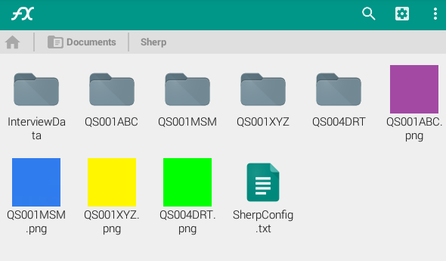

The InterviewData folder is initially not present. It is created the first time when an interview is conducted. This folder holds the interview data in form of a JSON file – interviewdata.json.

QS001ABC, QS001MSM, QS004DRT, QS001XYZ are folders containing the config files for the respective QAsets.

The config files contains :

1. The usernames of the interviewers who are permitted to interview those QASets.
2. An id assigned to the tablet, known as device id.
3. List of venues where interviews will be conducted.
4. The last_interviewee_id is updated after every interview is conducted.

You can edit the values(only) with the edit icon on the top left corner of the screen.

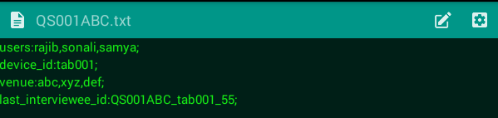

The sherp config file lists all the QASETs and their details.

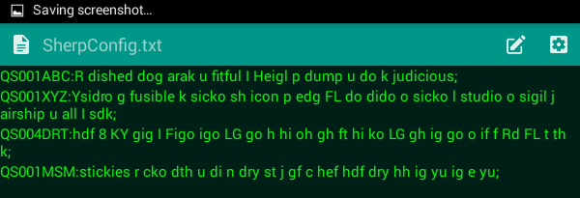

The logo for each of the QAset is also present in the SHERP folder.

Each logo is named after its respective QASet.

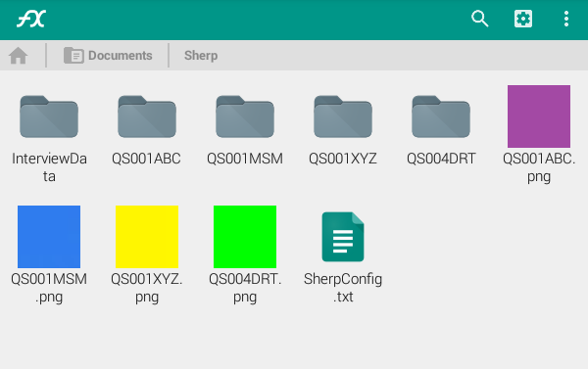

Once you are done with the folder setup, install the apk file.

It is essential for you to turn on GPS services in your tab before you start using the app. This is help you in getting your present location.

On clicking the app open, you are asked to select the qaset you want to interview.

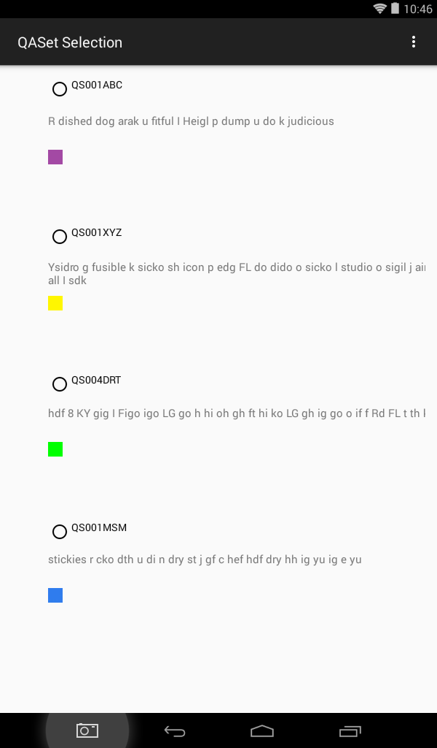

On selecting any one, the next button appears, accompanied by a message stating the selected QAset.

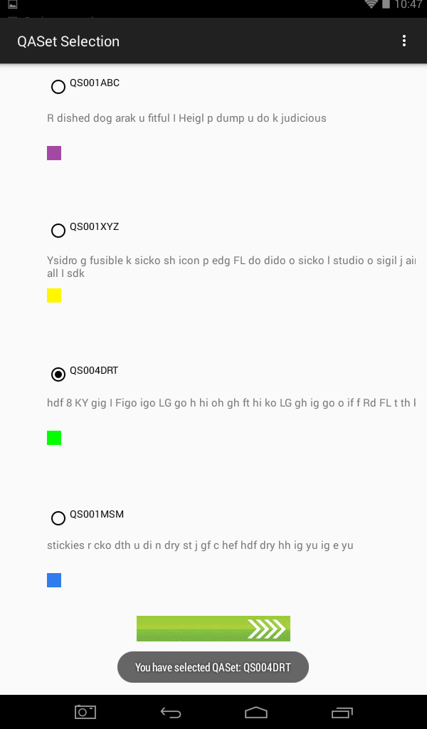

On clicking next, you are taken to the login page for that specific QAset.

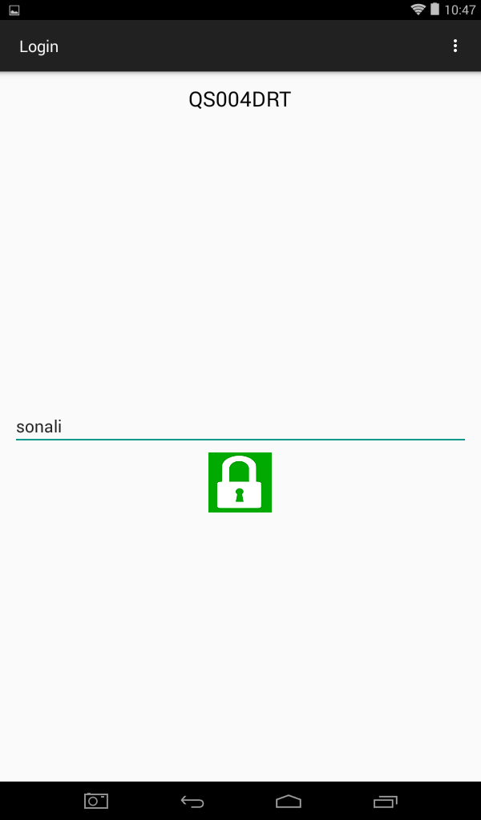

You can see the QASet name on the top. Key in your username and click on the Lock image to login.

Clicking on Login without keying in your username gives you a message - “Username required.”

Keying in a username not present in the QASet config file gives you a message- “Access denied.”

On successful login you are taken to the consent form screen.

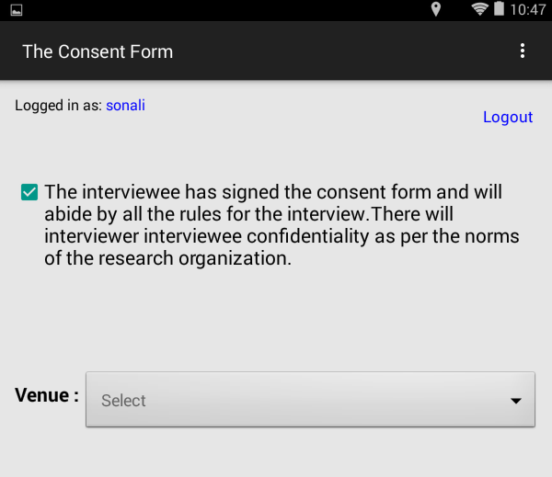

This screen shows who is presently logged in. This screen also has a logout option on the top left corner of the screen.

On checking the consent form signed checkbox, the venue button becomes visible. Once you select a venue you are displayed your current location details (Latitude, Longitude) along with the ‘Start Interview’ image button.

If you uncheck the consent form signed checkbox, the venue dropdown, the location details and the ‘start interview’ image button becomes invisible.

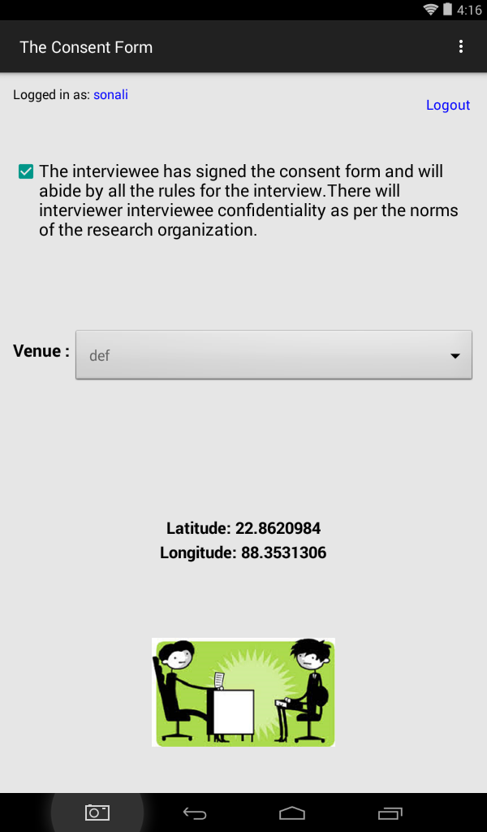

On clicking the ‘Start Interview’ image button you are taken to the first interview question.

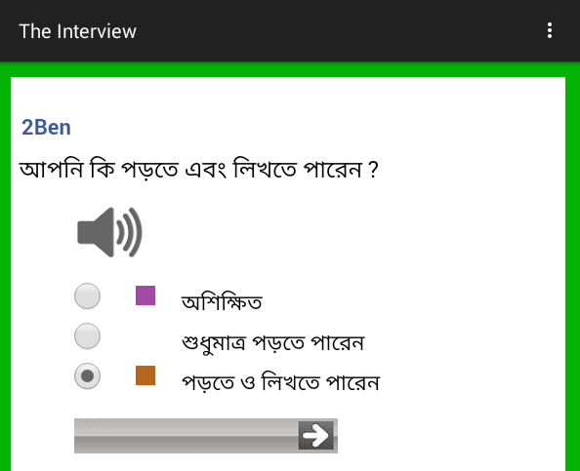

In the first question, you are asked to select the preferred language.

You cannot move forward without answering a question. Any attempt to do so will give you a message- “Please select an answer before you proceed!”

Each question is accompanied by its audio version. Click on the speaker image to play the audio file.

Answers are color coded to benefit better understanding for the people who can’t read.

You cannot go back from this page.

Once the interview is done, you are displayed the next screen which:

* displays the current interviewee ID.
* shows you a message saying interview data has been successfully saved to device.
* shows you another message saying the current interviewee Id has been updated to the config file.
* Has an image button to start another interview with the same QASet.

To conduct an interview with a different QASet, you would need to logout.

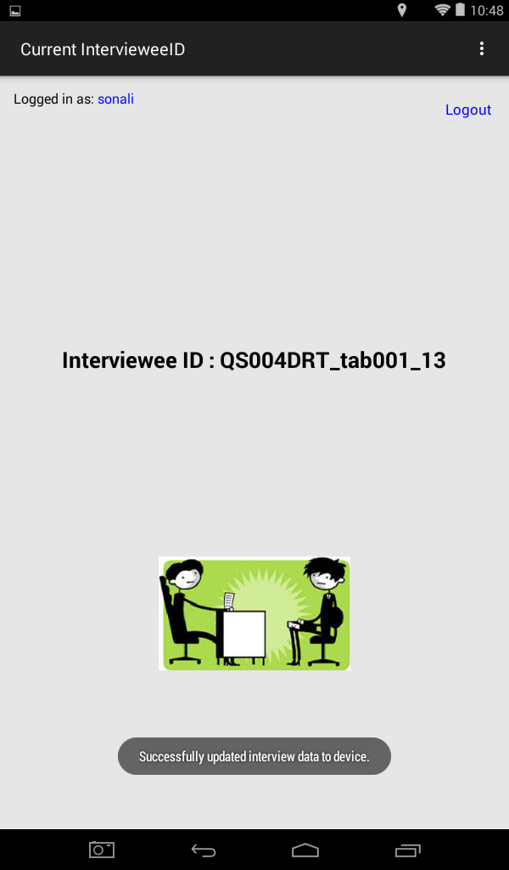

**“The SHERP - Upload app”**